Application Note: Frequency Offset Configuration User Guide
AN-FBD-EVK-UG-E6
Ver 1.0
2018/02/09
Brief：
This application note mainly introduces the problem solving method during the manufacture procedure.

lenze technology co., LTD

Published by
lenze technology co., LTD

Room C,26th FIoor,West Speclal Zone PressBuilding,NO,6008Shennan
Road,Futian District Shenzhen

© lenze technology co., LTD
All Right Reserved

Legal Disclaimer
lenze technology co., LTD reserves the right to make changes without further notice to any products herein to improve reliability, function or design. lenze technology co., LTD disclaims any and all liability for any errors, inaccuracies or incompleteness contained herein or in any other disclosure relating to any product.

lenze technology co., LTD does not assume any liability arising out of the application or use of any product or circuit described herein; neither does it convey any license under its patent rights, nor the rights of others

The products shown herein are not designed for use in medical, life-saving, or life-sustaining applications. Customers using or selling lenze technology co., LTD products not expressly indicated for use in such applications do so entirely at their own risk and agree to fully indemnify lenze technology co., LTD for any damages arising or resulting from such use or sale.

Information:
For further information on the technology, product and business term, please contact lenze technology co., LTD Company (www.lenzetech.com).
For sales or technical support, please send email to the address of:

Revision History
Version | Major Changes | Date | Author
1.0 | Initial release | 2018/2 | Caroline Yang

Overview
This application note mainly introduces method and steps about how to deal with the unstable connection between Android Phone and peripheral devices, as well as firmware debugging.
Since the unstable connection is usually caused by abnormal frequency (which may relate to the precision of crystal oscillator,17H2X chip ,or PCB conditions )or TP value which relates to the link states. And as long as the Bin file is less than 0x3fe0 and TP value will still be the default value which won’t effect the link states of Blue tooth .
In this document, an IOS or Android device and a dongle board are used as the frequency test examples.

Method one -we strongly recommend this
if the Precision of the 12MHZ crystal oscillator is bigger than 1%,then we have to use two 16pF capacity with a precision of 1%, to correct the frequency offset of crystal oscillator .So to speak ,give the 17H2x chip an accurate clock.
To use this method we have to call ‘set_freq_offset_OTP(0x56);’ command .
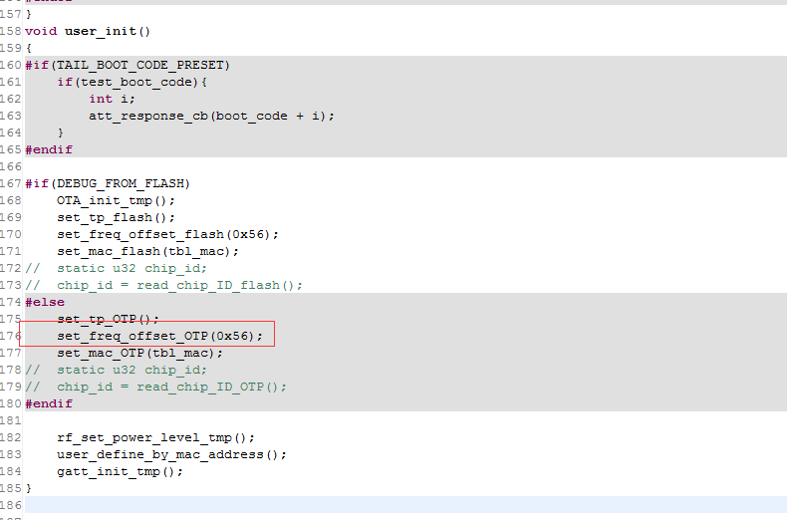
below is the realization of ‘set_freq_offset_OTP(0x56);’, now it’s been integrated into the “liblt_17H26_0110.a” file.
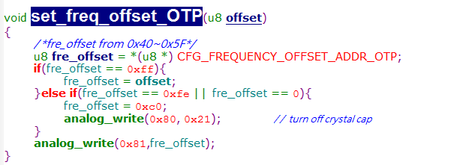

And at the same time we have to write 0xfe into 0x3fe8,in order to use a crystal oscillator external matching capacitor.
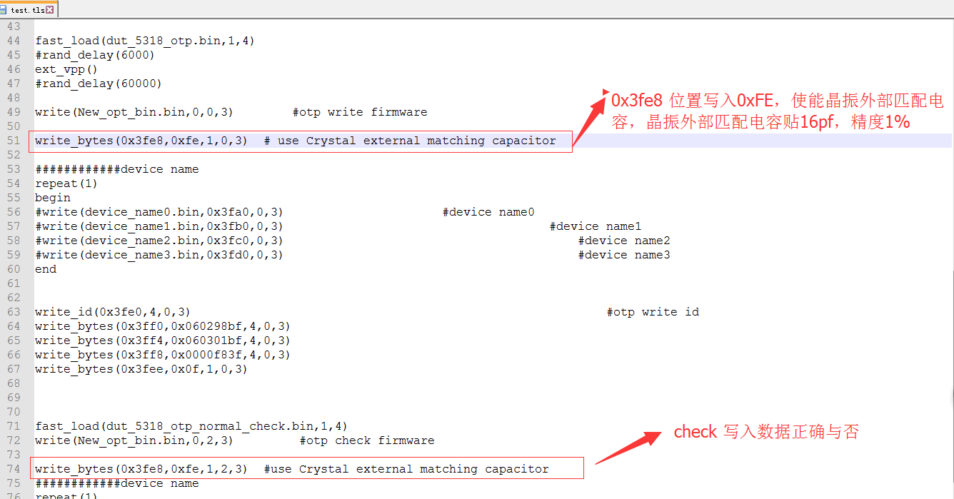

3 Method two
In this method we use a crystal oscillator internal matching capacitor,which won’t have to change the value of 0x3fe8 within “test.tls” loading Bin file . and you can just use a # in front of the write_bytes(0x3fe8,,0xf3,1,2,3); to cover this command.
But this method usually depends on the consistency of the 17H2x series chip,if a mass number of the chip encounters the precision problems then ,you have to correct them one by one use the special tools .So for method 2’s inefficiency ,we recommend the method 1 .

